Prometheus and Grafana

Step 1:

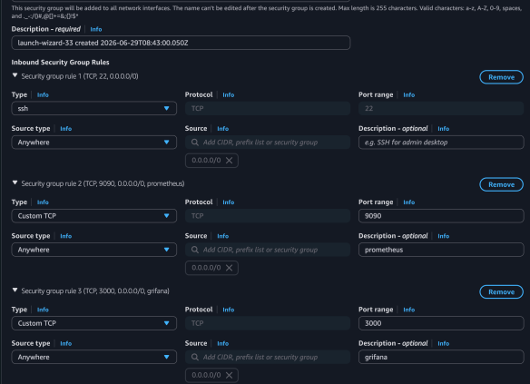

Step 2:
Create Prometheus Systemd Service

Step 3:

Step 4:
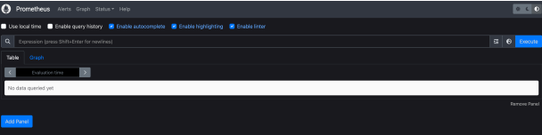

Step 5:
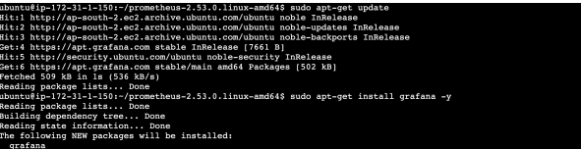

Step 6:

Step 7:


Step 8:
Connecting grafana with prometheus

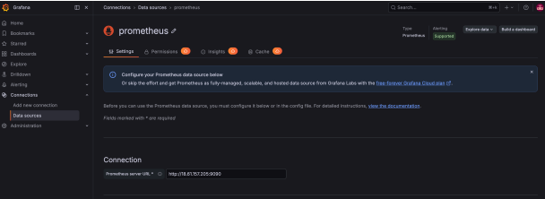

Step 9:
Creating Dashboard

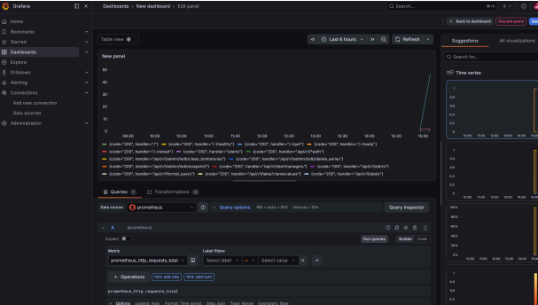

Step 10:

